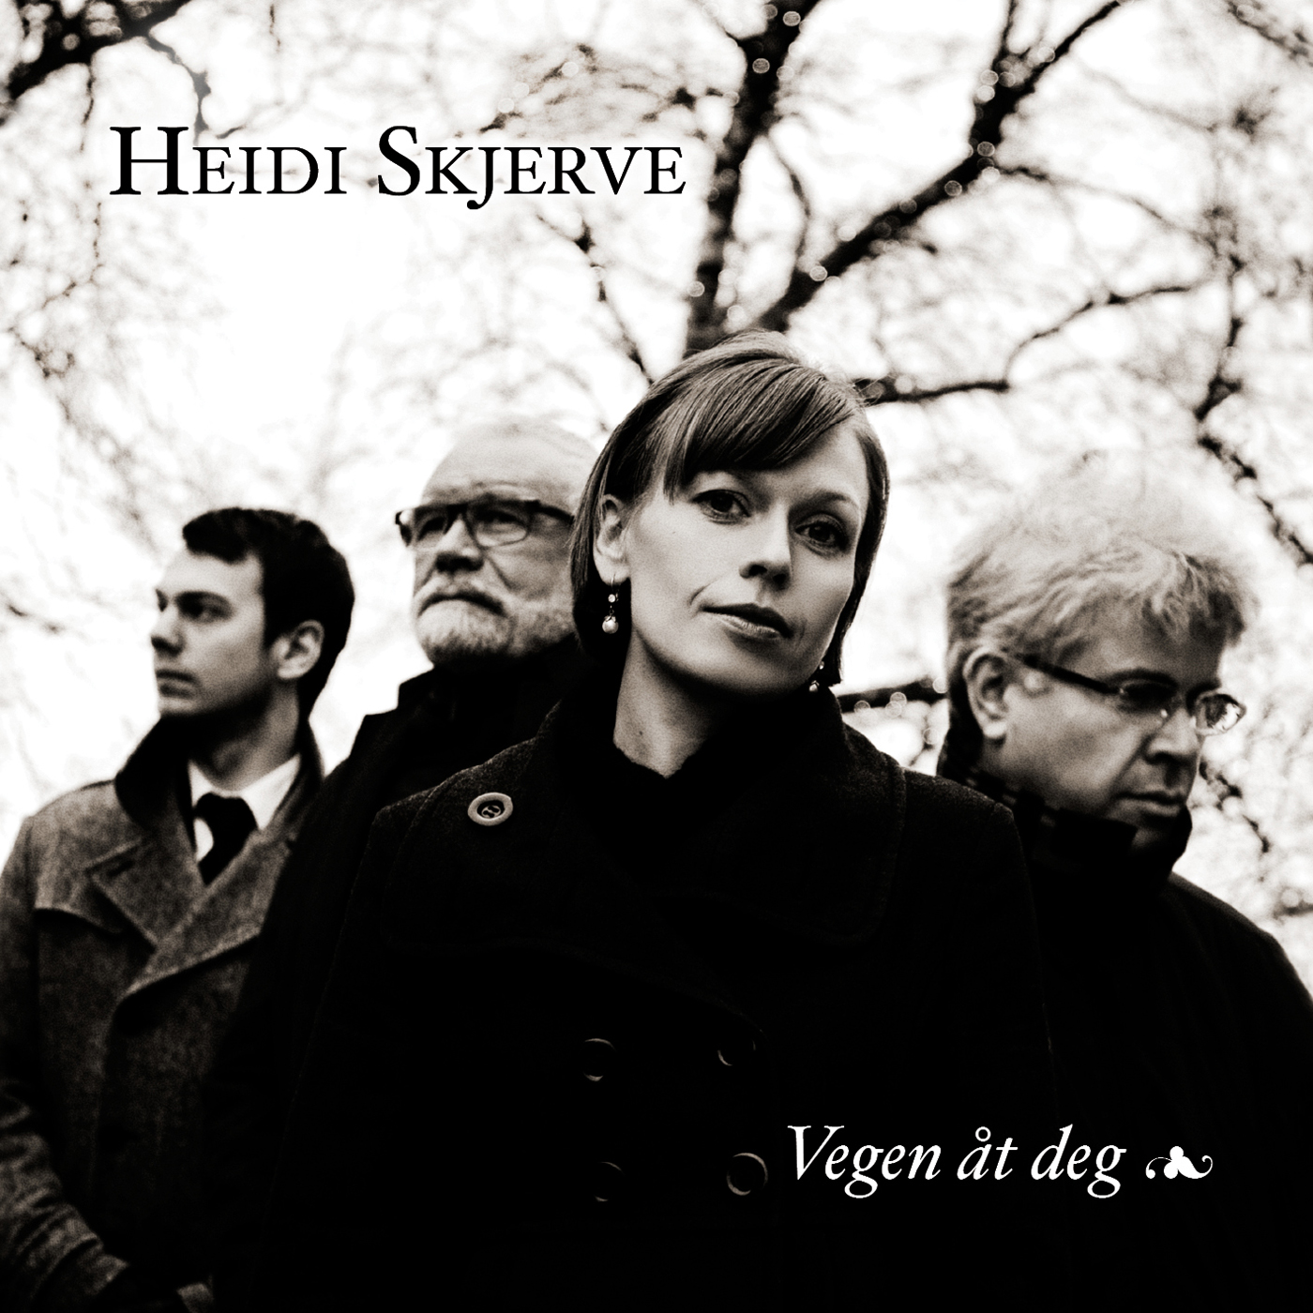
VEGEN ÅT DEG
THE ROAD TO YOU
New CD out 2012.11.28.

Heidi Skjerve: Vocal
John Pål Inderberg: Baryton Saxsophone
Vigleik Storaas: Piano
Trygve Waldemar Fiske: Double Bass

Traditional folk songs, hymns and dance music from Mid-Norway, presented by a reputable jazz quartet, with a playful attitude and a great respect for the old traditions. Completed with songs written by Heidi Skjerve and lyrics by local poets. With great sincerity they use Imagery from nature to speak of charity, love and lust, longing, the artists urge, and the art of life itself.

The album ”Vegen åt deg” (The road to you) was recorded and mixed at Øra Studio during October 2012 and will be released 28th of November 2012 at Øra Fonogram.

This recording was supported by: Government Grants for Artists, The Norwegian Musicians Union (MFO), Rennebu municipality, Trondheim municipality and Meldal Sparebank.

The prosject "Jazz from the woods" was presented for the first time during Trondheim Jazzfestival 2011, live recorded and broadcasted by NRK radio.

About the musicians:
Heidi Skjerve has previously released two albums with her own music at the label Curling Legs. She is also a member of the vocal group Trondheim Voices, an improvising ensemble of soloists, that has performed at a number of large festivals and cooperated with artists and composers such as Jon Balke, Marilyn Mazur, Mats Gustafson, Eldbjørg Raknes, Ståle Storløkken, Circa Teater and more. Heidi has been featured as a soloist with the folk music trio Flukt, Trondheim Jazzorchestra, The Norwegian Air Force Band, and a lot of local big bands and choirs all around Norway.
John Pål Inderberg is a versatile saxophonist with a natural spontaneity of expression. His playing sythethises many different styles, not least when in partnership with Norwegian and American jazz musicians - players as contrasting as Gil Evans and Lee Konitz. Inderbergs soprano and baritone sax can be heard on a wide range of recordings and, besides his performing career, he is a professor at The department of Music NTNU.
Vigleik Storaas is an experienced and reputable pianist and composer who has performed with such as Chet Baker, Warne Marsh, John Surman, Karin Krog, NHØP, Palle Danielson as well as the leading Norwegian jazz musicians and Trondheim Jazz Orchestra. He has recieved "Spellemannsprisen" (The Norwegian "Grammy") twice.
Trygve Waldemar Fiske is an young up-and-coming bassplayer who has already made a mark on the Norwegian and Scandinavian jazz scene, with bands sunch as Hanna Paulsberg Concept who won the Young Nordic Jazz Comets i 2011.

CONTACT:
Heidi Skjerve - www.heidiskjerve.com
heidi@heidiskjerve.com
Tlf: 915 92 538

Label: Øra Fonogram - www.oramusikk.no
post@orastudio.no
steinar@orastudio.no
Steinar Larsen tlf: 90834665

Distribution: Musikkoperatørene
ordre@musikkoperatorene.no
Tlf: 23310120

